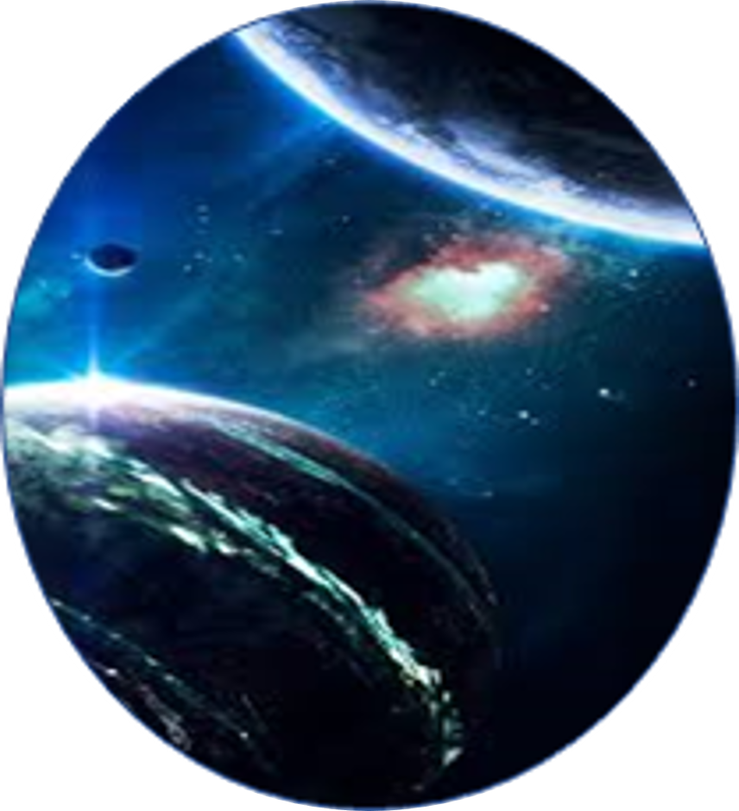

**MY EARTH**

**WHAT’S ALL ABOUT?**

Did you know that NASA studies the Earth in addition to other planets? This application contains everything people need to know about NASA’s Earth Science Division (ESD) missions. ESD helps us understand our planet’s interconnected systems, from a global scale down to minute processes.

*The MY EARTH application is developed to tell stories of NASA’s Earth science enterprise using interactive digital tools as gamification, because statically people tend to learn and grasp more informations if they’re comfortable and having fun at the same time.*

Aiming the education of people about the previous earth hazards and telling historical stories of NASA Earth science missions, events, scientists and technology by sending updates and providing users with simplified information using NASA’s data, this will help the user to develop a scientific understanding of the Earth system and its response to natural and human-induced changes and to learn about improved prediction of climate, weather, and natural hazards for present and future generations.

**Goals tackled by the app:**

My Earth is an app that helps users to sharpen their knowledge about Nasa’s history. With its content of NASA’s data and missions on earth, our fun and educational game tackles the following goals:

**Goal 1**: Education of people about the Nasa earth science studies



**MY EARTH**

**Goal 2:** Learn characteristics dates and important events about Nasa earth science history

**Goal 3:** Providing simple explanations of complicated NASA’s earth themed subjects

**App categories:**

**Category 1 : GAME MODE**

On the first category the user can enjoy playing earth themed games. The easy level contains puzzles and the medium level contains a match three puzzle.

Every time he unblocks a level a pop up message will appear congratulating him. This message will contain either an information about a historical Nasa earth mission or astronauts\scientists that contributed in Nasa’s earth missions.

**Category 2 : ADVENTURE MODE**

On this category the user can follow NASA’s missions throughout the years using a timeline discovering along the way lot of fascinating informations .



**MY EARTH**

**App features:**

-This application collects data from NASA and provides users with simplified informations about NASA earth science and history they need to read to enhance their knowledge about Earth.

- The latest NASA’s Earth news

- The user can read historical informations he unblocked in a more detailed article in the ACHIEVEMENTS

- The ability to choose the hazard you like to get information about

**Future updates:**

-A VR implementation so that the user can discover: Satellites from the inside

-A game where the user can create his own phenomena

-Short animated videos where the user explores NASA’s history in details

-The adventure mode will also give the user the ability to create a virtual volcano and to virtually experience different earthquake magnitudes